
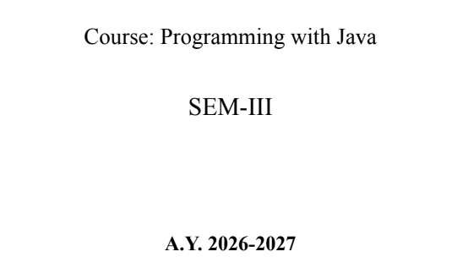
NAME: BHOOMI VIJAYVARGIYA
BATCH: A2
PRN: 25070122062

ASSIGNMENT No : 11
TITLE : Write a Java program to demonstrate the implementation of interfaces.
Problem Statement Write a Java program to demonstrate the implementation of interfaces.
Learning Objectives To implement interfaces for achieving abstraction and multiple inheritance of type.
Theory
An interface specifies a set of abstract methods that implementing classes must define. It provides complete abstraction and supports multiple inheritance of type. Interfaces improve modularity, loose coupling, and software flexibility. They allow different classes to implement common behavior while maintaining independent implementations. Interfaces are widely used in enterprise application development.
Code
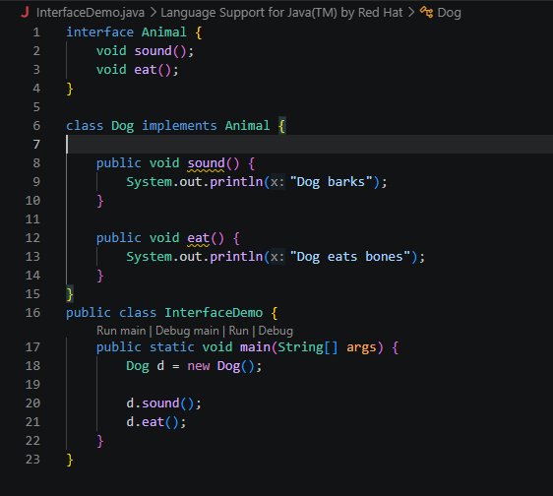
OUTPUT
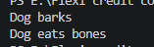
Outcome
Implemented interfaces in Java to achieve abstraction and allow different classes to provide their own implementation of common methods.
Conclusion
This program demonstrates how interfaces promote code reusability, flexibility, and multiple inheritance of type by enabling different classes to implement the same interface in their own way.
Exercise
- Create an interface Printable and implement it in Student and Employee classes.
Code:
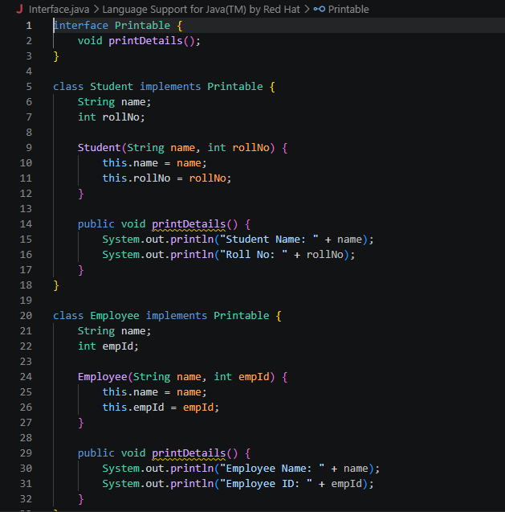
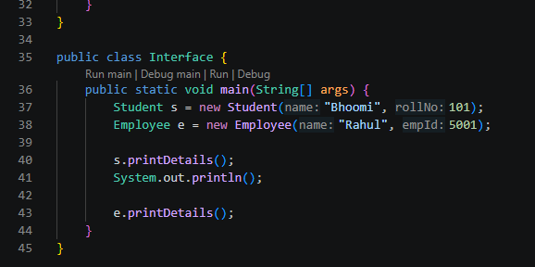
Output:
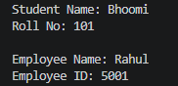

- Create an interface Switchable with a method turnOn(). Implement the interface in Light and Fan classes to display the device status.
Code:
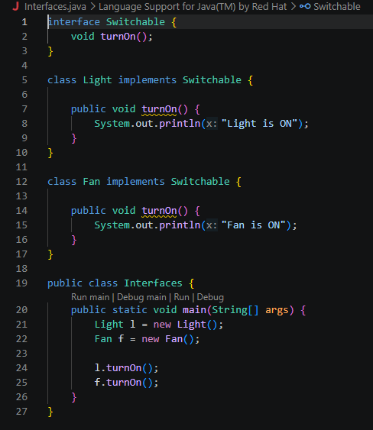
Output
